Sanjivani Rural Education Society’s

**Sanjivani College of Engineering, Kopargaon-423603**

*(An Autonomous Institute Affiliated to Savitribai Phule Pune University, Pune)*

(NAAC ‘A’ Grade Accredited, ISO 9001:2015 Certified)

**Department of Information Technology**

(NBA Accredited)

**CERTIFICATE**



College Logo

This is to certify that the Project entitled***“Game"*** submitted by

Borude Shantanu Vilas [Exam Seat no:UIT20M1014 ]

Jadhav Abhishek Vinayak[Exam Seat no:UIT20M1029]

Jagdhane Rahul Kailas [Exam Seat no:UIT20M1030]

Jeughale Shreyas Devanand [Exam seat no:UIT20M1032]

is a record of bonafide work carried out by them in partial fulfilment of the requirement of Degree of Bachelor of Technology in Information Technology at Sanjivani College of Engineering, Kopargaon under the University of Pune during academic year 2021-2022.

**Devyani Jadhav Dr.M. A. Jawale Dr. A. G. Thakur**

**Project Guide Head of IT Dept. Director**

Examiner 1: *(Name and Signature)*

Examiner 2: *(Name and Signature)*

**Place**: S.R.E.S’s Sanjivani collegeof Engineering, Kopargoan

**Date:**

Project Report on

**GAME**

Submitted by

BorudeShantanu Vilas [Exam Seat no:UIT20M1014 ]

JadhavAbhishekVinayak[Exam Seat no:UIT20M1029]

Jagdhane Rahul Kailas [Exam Seat no:UIT20M1030]

JeughaleShreyasDevanand[Exam seat no:UIT20M1032]

Under the Guidance of

Prof. D. P.Bhamare

**S. Y. B.Tech**

**[Information Technology]**



**DEPARTMENT OF INFORMATION TECHNOLOGY ENGINEERING**

**SRES's SANJIVANI COLLEGE OF ENGINEERING, KOPARGAON**

**2021-2022**

I

**ACKNOWLEDGEMENT**

The entire session of Mini- Project completion phase so far was a great experience providing us with great insight and innovation into learning various data security concepts and achievement of it. As is rightly said, for the successful completion of any work, people are the most important asset our project would not be materialized without the cooperation of the people involved.

First and foremost, we are very thankful to our respected project guide Prof. D. P. Bhamare for their leading guidance and sincere efforts in finalizing this topic. They took deep interest in correcting the minor mistakes and guided us through our journey so far. Also, they have been persistent source of inspiration for us.

We are also very thankful of Dr. M. A. Jawale, Head of Department of Information Technology for the symmetric guidance and providing necessary facilities and we express deep gratitude to all the faculty members and our department’s technical Staff for providing us needed help.

Borude Shantanu Vilas [Exam Seat no:UIT20M1014 ]

Jadhav Abhishek Vinayak [Exam Seat no:UIT20M1029]

Jagdhane Rahul Kailas [Exam Seat no:UIT20M1030]

Jeughale Shreyas Devanand [Exam seat no:UIT20M1032]

II

**Abstract**

Games are well- known among children even among matured people. The rules and regulations of the game are well-known as the regular game. The case study meant for implementing this game without losing its attraction. This games comes with a single player mode. This Game in python is an easy game for all. The graphics of the gameplay system is good and smooth to control for the users. Talking approximately the gameplay of the system, the gambling strategies are too easy, all you need to do is simply pass round and hit enemies or protect from enemies through moving rikshwas. In this Game the user has to manage a rickshaw. The game is controlled through a keyboard (up, down, right, left arrow keys). It means that the more you crash or hit enemies through stones, the more a highest game score to get. When the crashes then the game is over and again you have to start a new game otherwise you win the game you switch to next level.

**Contents**

Acknowledgement I

Abstract II

Abbreviations III

List of Figures IV

|  |  |  |  |  |  |  |  |  |  |  |  |  |  |  |  |  |  |  |  |  |  |  |  |  |  |  |  |  |  |  |  |  |  |  |  |  |
| --- | --- | --- | --- | --- | --- | --- | --- | --- | --- | --- | --- | --- | --- | --- | --- | --- | --- | --- | --- | --- | --- | --- | --- | --- | --- | --- | --- | --- | --- | --- | --- | --- | --- | --- | --- | --- |
| |  |  |  |  | | --- | --- | --- | --- | | **Sr.** | | **Chapter** | **Page No** | | **1.** |  | **Introduction to game** | 01 | | **2.** |  | **Objectives** | 02 | | **3.** |  | **Scope of Project** | 03 | | **5.** |  | **System Architecture** | 05 | | **6.** |  | **Implementation** | 06 | | **7.** |  | **Advantages and Disadvantages** | 08 | | **8.** |  | **Conclusion** | 10 | | **9.** |  | **References** | 11 | |

**INTRODUCTION**

A **game** is a structured form of play, usually undertaken for entertainment or fun, and sometimes used as an educational tool. Games are different from work, which is usually carried out for remuniration, and from art, which is more often an expression of aesthetic or ideological elements. However, the distinction is not clear-cut, and many games are also considered to be work (such as professional players of spectator sports orgames) or art (such as puzzle or games involving an artistic layout such as mahion, orsome video game).

Games are sometimes played purely for enjoyment, sometimes for achievement or reward as well. They can be played alone, in teams, or online; by all age group of people.

 part of the entertainment for children playing a game is deciding who is part of their audience and who is a player.

In our game we are creating GUI for some different types of levels and menu used in game for activity of objects and for different levels which are after the winning gameand also loosing game in that different types of game at different levels.

1

**OBJECTIVES**

**1**. Learn the python language with its different Types of application.

2.LearnTo Construct Graphical User interfaces(GUI).

3. A Fun experience.

4. Improves overall skill ceiling.

5.Build An interactive Ability useful for programming projects.

6. Develop Games with Deep learning **.**

7.To provide add on game on functionality ,create graphics , and script various part of game

8.Using Pygame in future develop a video games

9. Python and pygame is a good lang. and framework for beginners.

10. Develop a good game with creating GUI, levels, animations.

2

**SCOPE**

1. Now a days gaming is become a very popular,and gaming industries growing very fast and trend.

2. New game development trends emerge every year and technology advances

3. It bringing great opportunities in future

4. We have implemented game is some basic level to creating object and movement of object.

5. Gaming is in trend infuture it becomes very popular

6. We want to implement our game in future in next level

7. Now a days people like to spend their time in enjoyment and that’s why not only children’s but also any age group of people are play games

8. During pandemics esports/games to rise in popularity,in future we want to make game which are playing by family also ,and make it in study oriented also.

9. The emergence of 5G is expected to bring technological breakthroughs and spur innovation in game.

10. In future making innovation in this existing game or system we can implement more prestigious games.

11. The purpose of this research or game is to virtual image for combination of both structure and unstructured information of our project.

3

**ER DIAGRAM**

|  |
| --- |
| Start game |

|  |
| --- |
| Proceed to GUI |

|  |
| --- |
| Proceed to level |

|  |
| --- |
| Repeat level |

[If lose]

[ If win]

|  |
| --- |
| Proceed to next level |

|  |
| --- |
| Final level |

|  |
| --- |
| Final level |

4

**Architecture**

|  |
| --- |
| Creating GUI, Object creation & moments. |
| Background effect (like parallax method), and linking the levels. |
| Background sound effect to game. |
| Creating opposite obstacles , creating animation. |
| Level shifting after win or lose condition. |

These are main steps or architecture that we follow to implemented our game.

5

**6**

Implementation

**Input for GUI:**

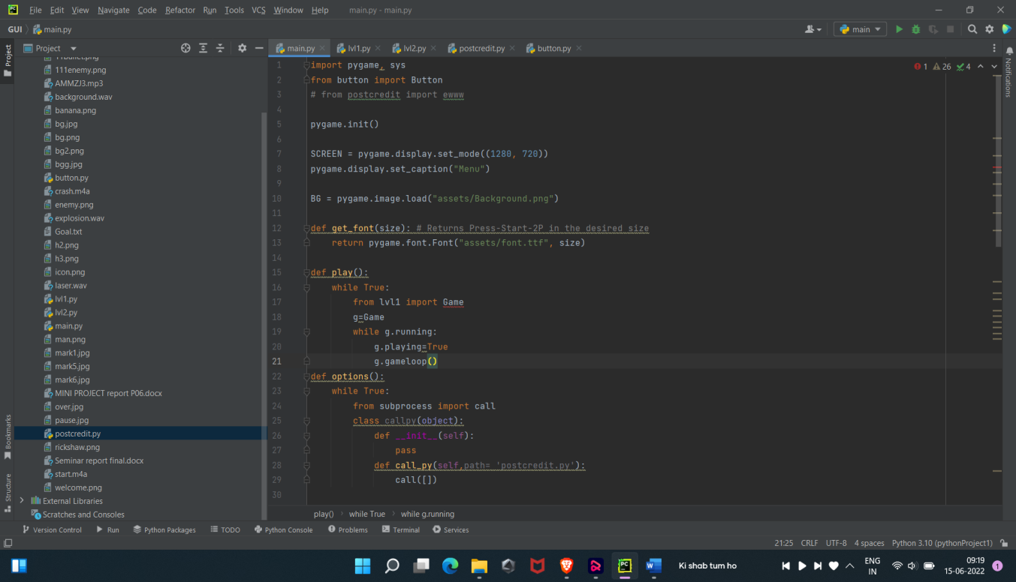

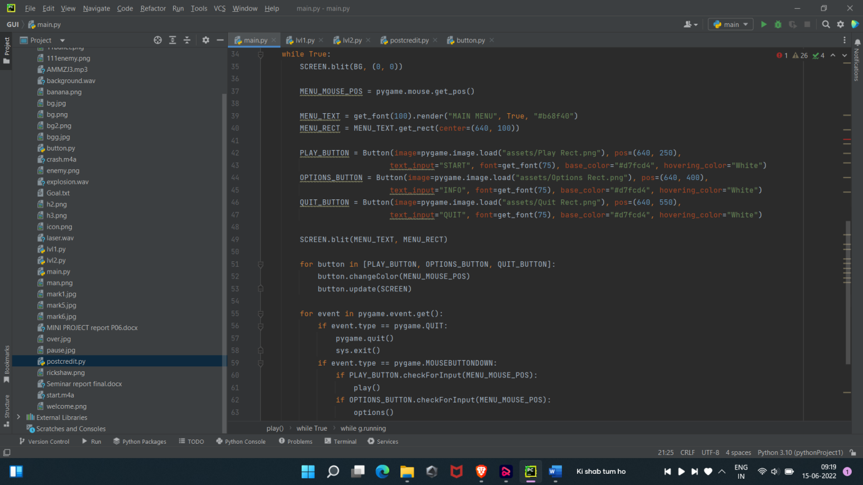

**Output:**

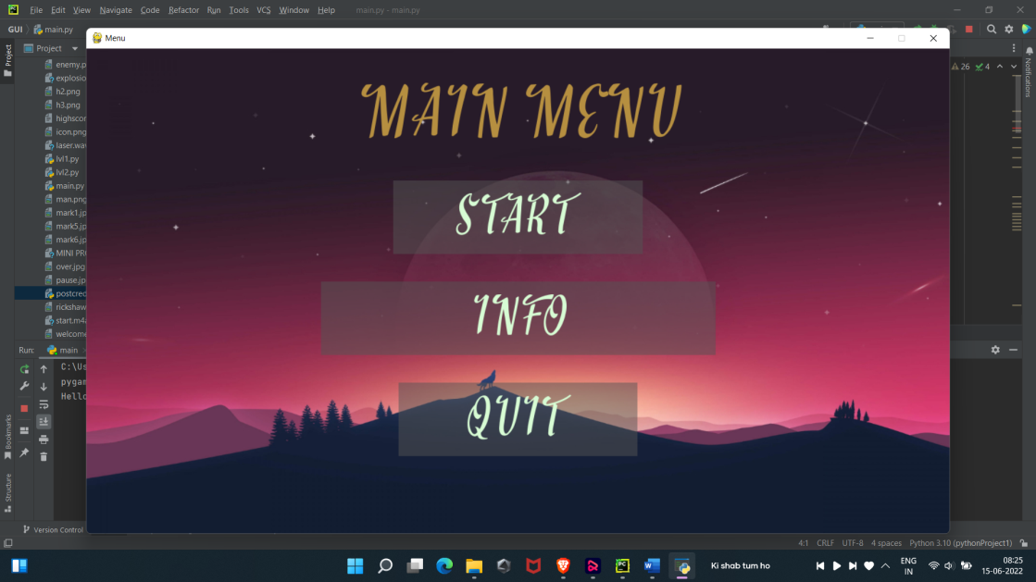

**Level 1 Source Code:**

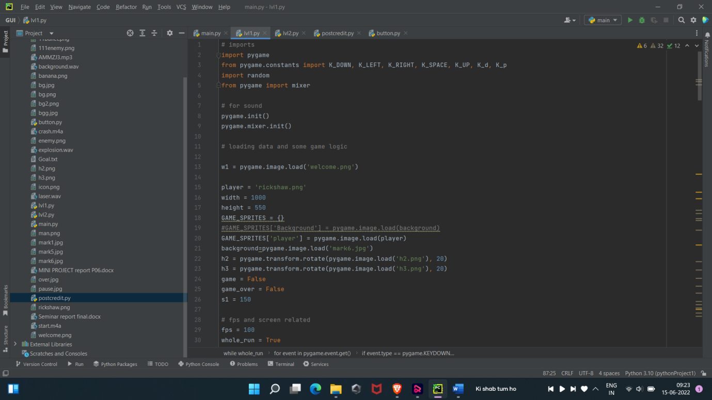

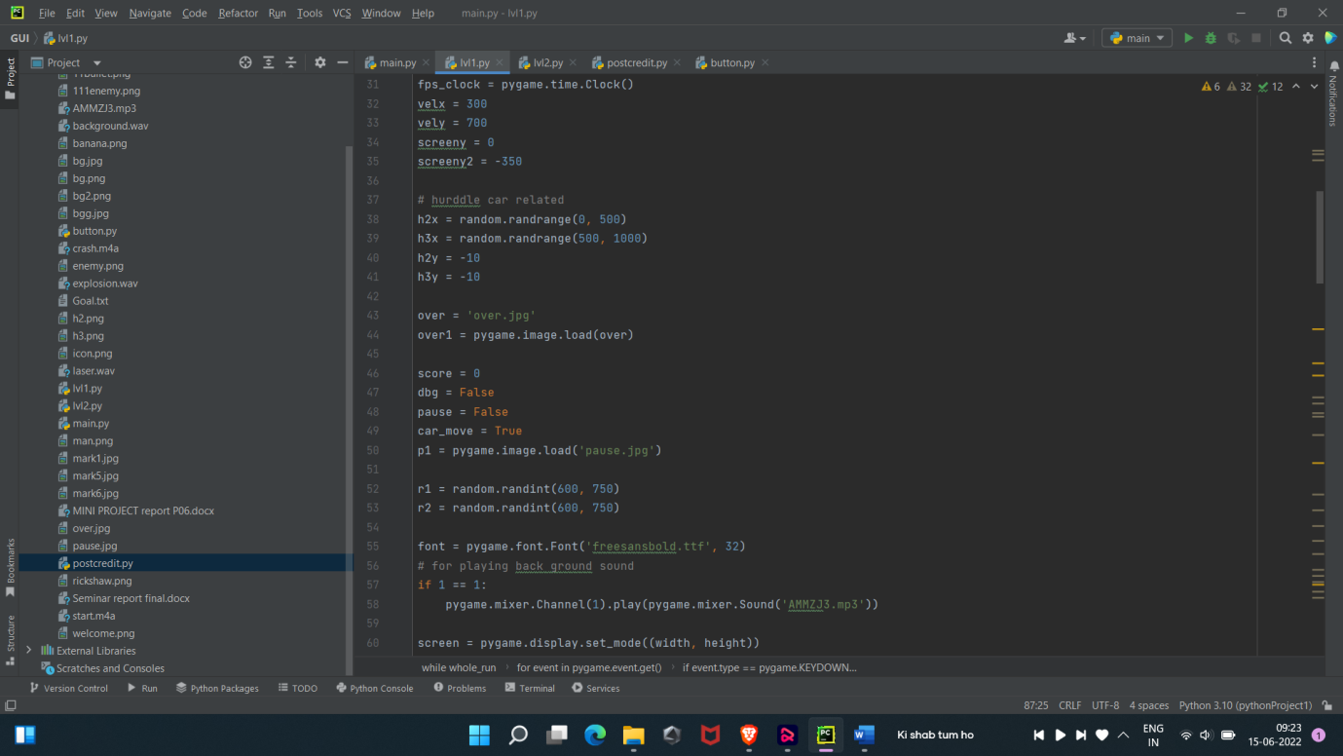

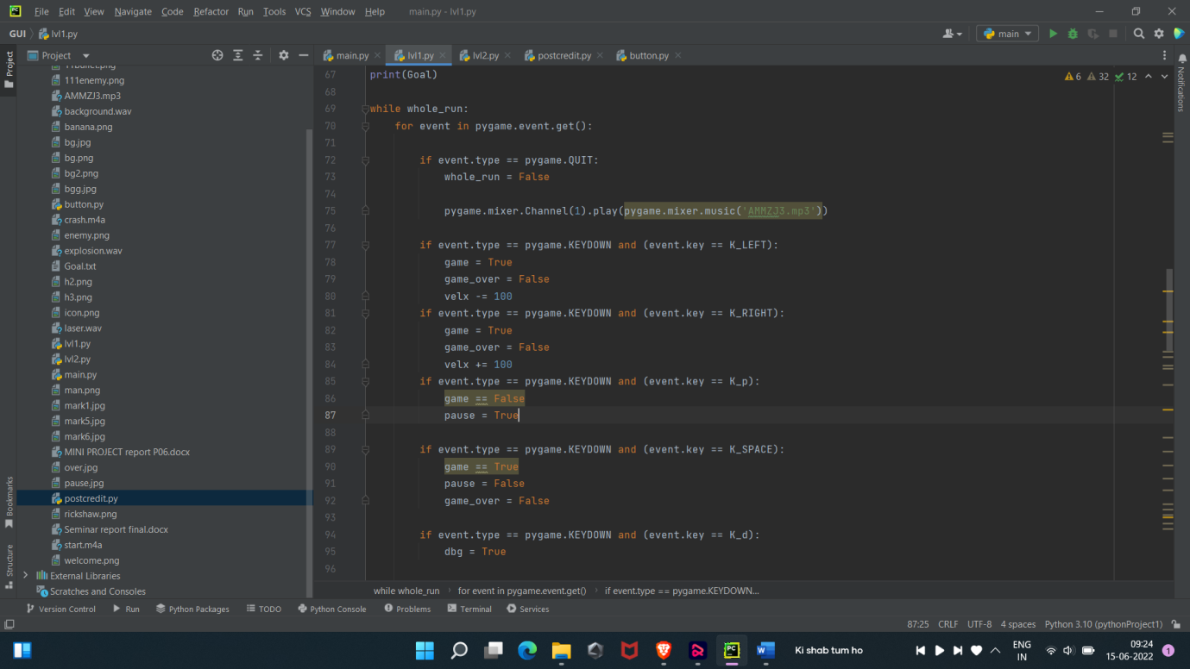

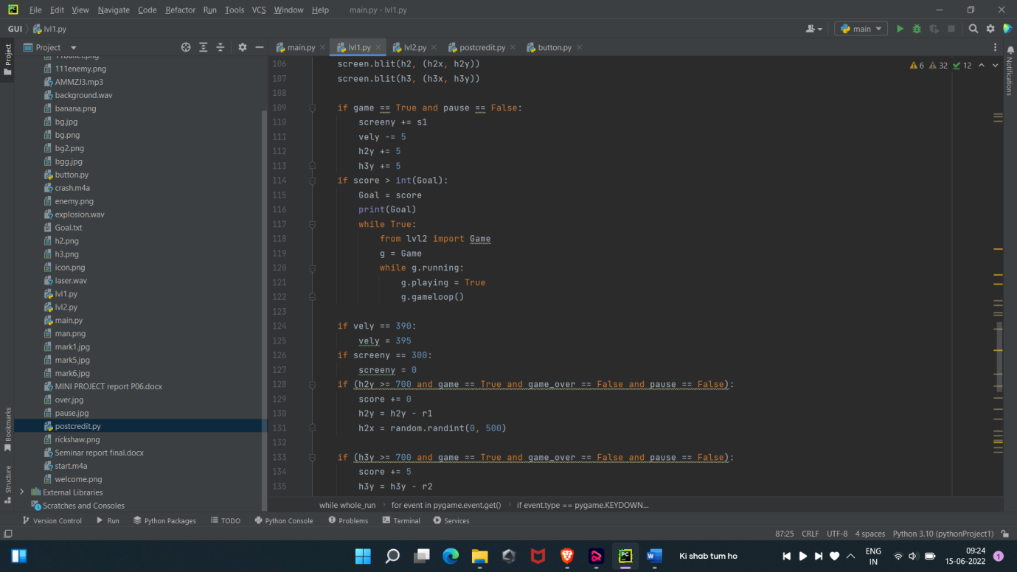

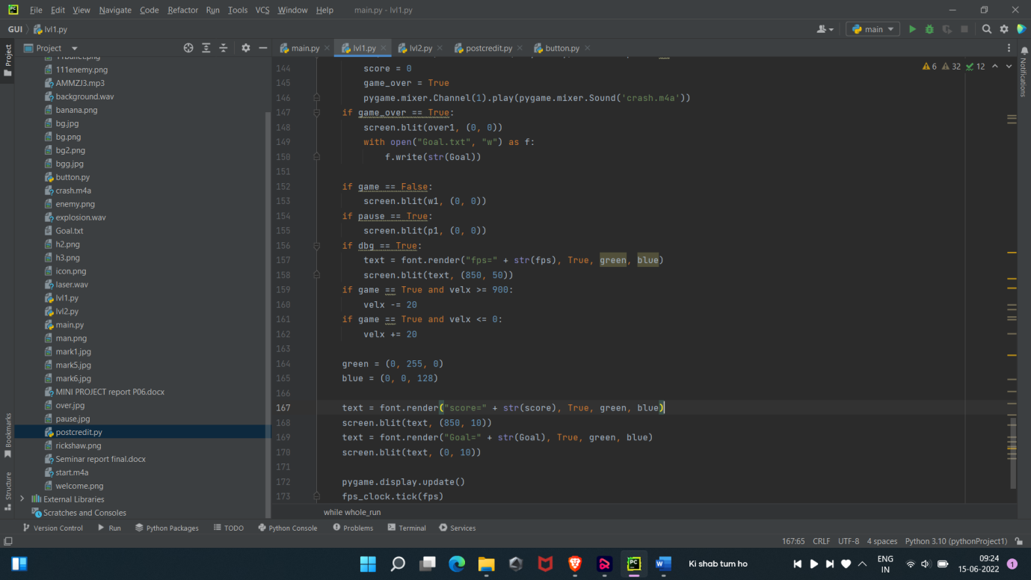

**Output for Level 1:**

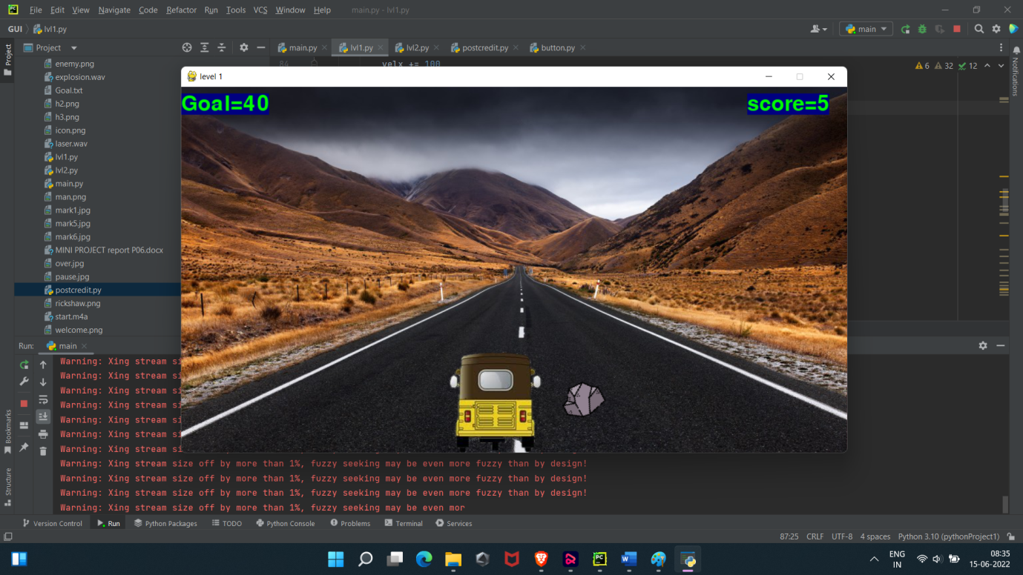

**Level 2 Source Code:**

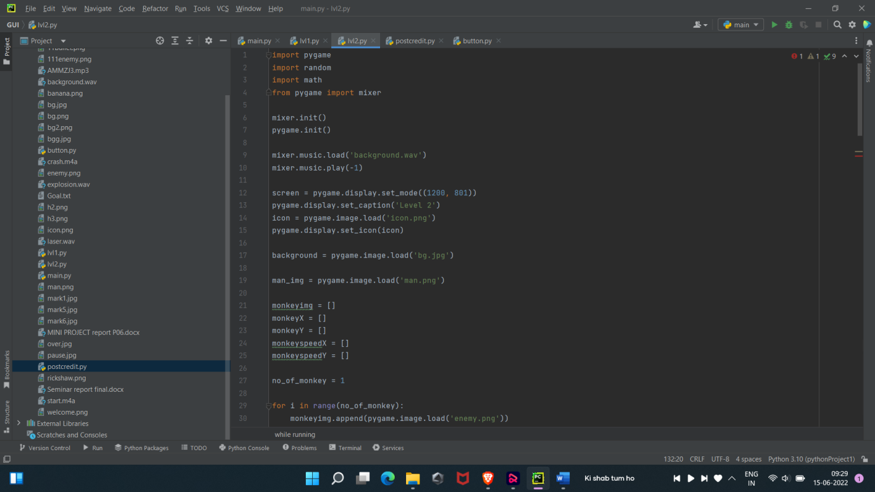

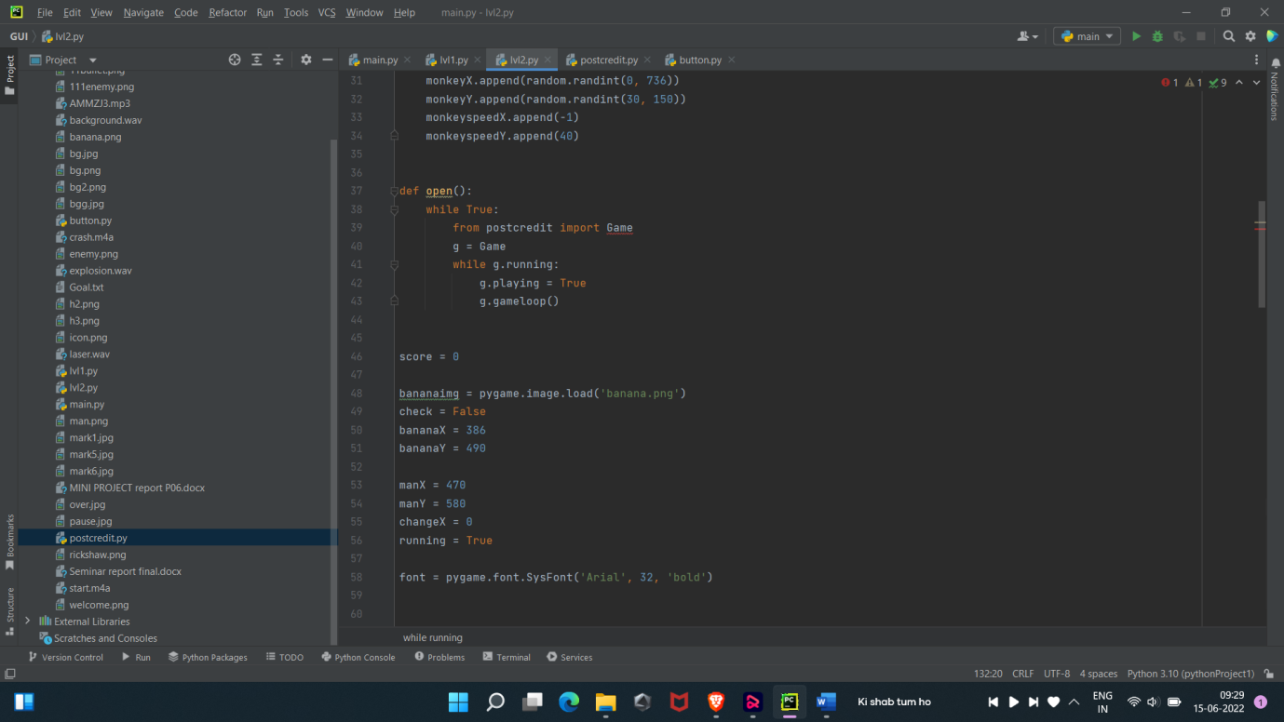

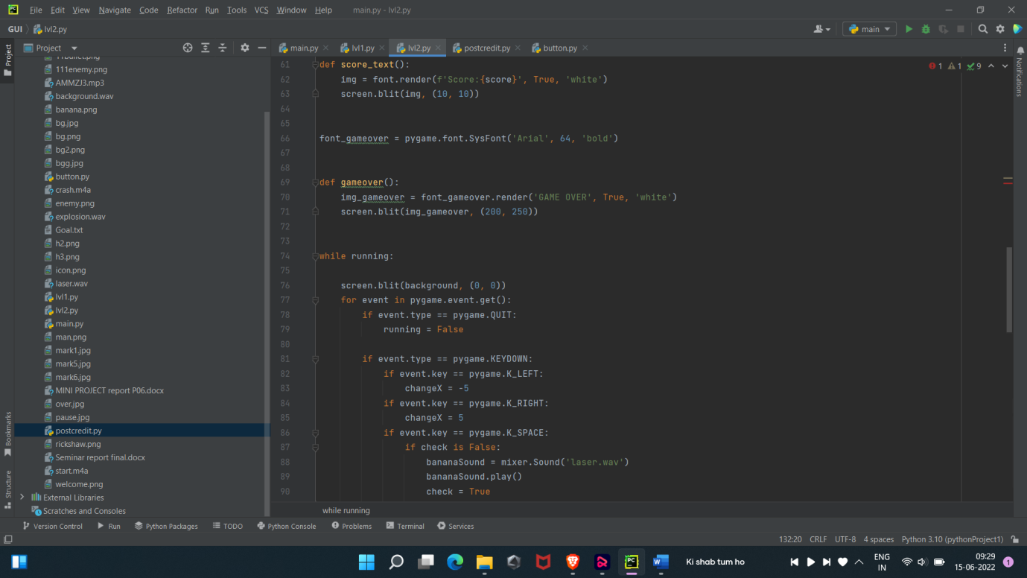

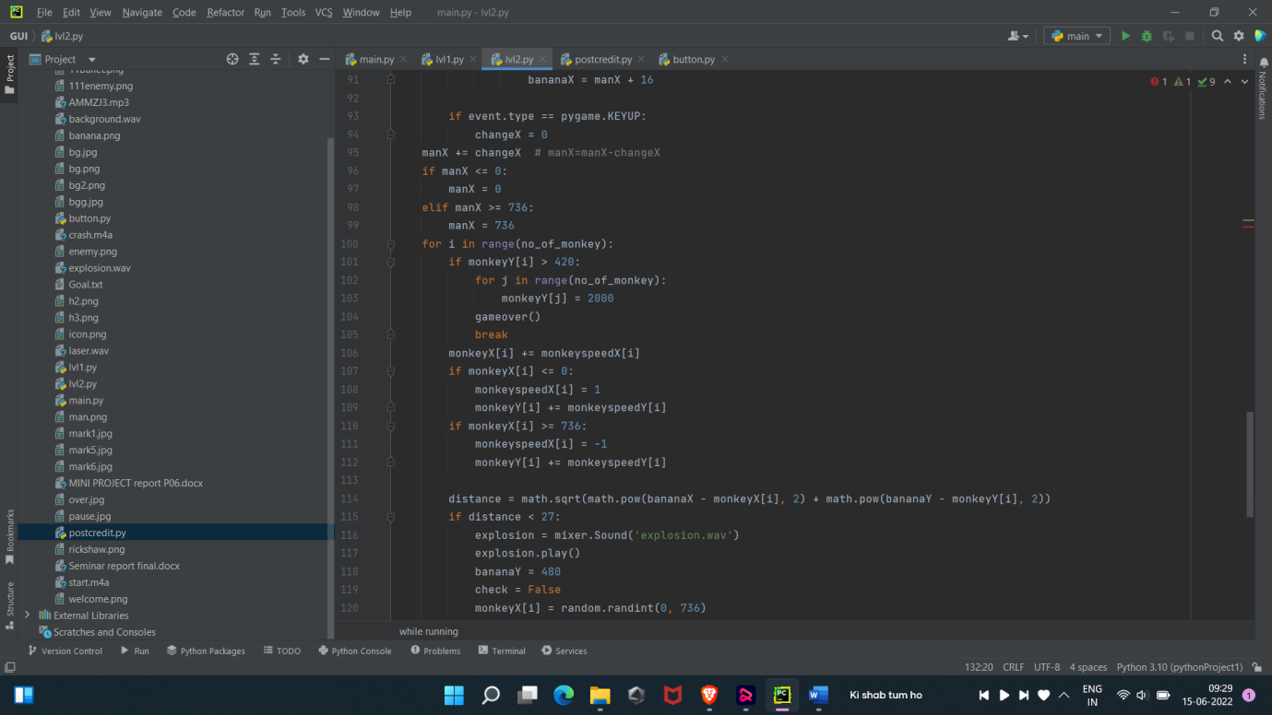

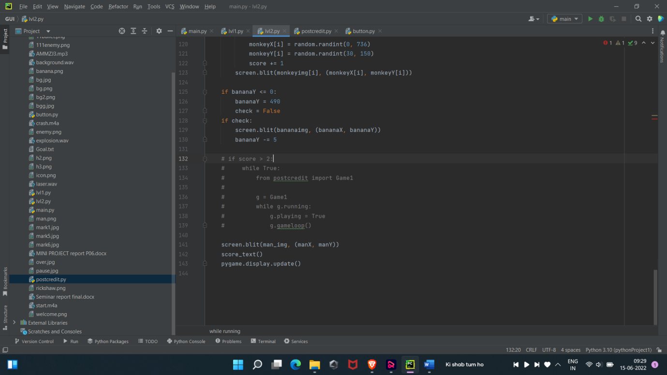

**Output:**

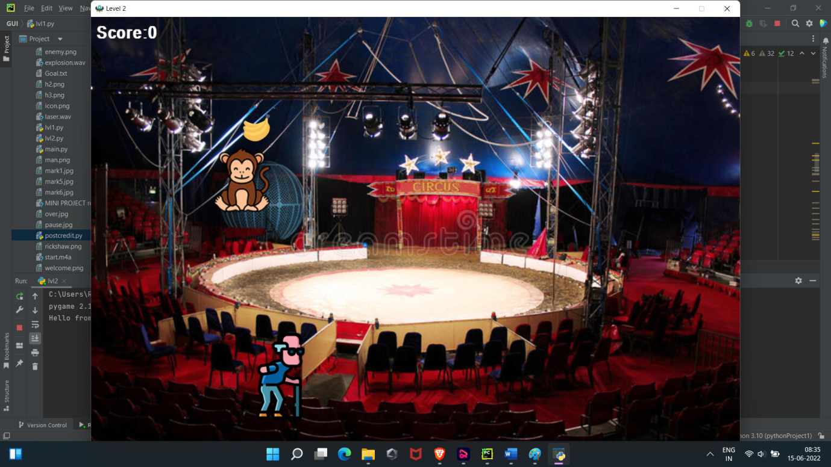

**Advantages and Disadvantages**

**Advantages:**  
1.Improved vision-studies suggest that game players may get better vision. they have been shown to increases ability to distinguish suitable differences in shades of gray.

2.Brain booster – playing game directly impact on regions of the brain responsible for memory, spatial orientation, information organizations, and fine motor skill.

3.Improveslife skills –

It involves taking risks, and the ability to strategize

, It give patience , perseverance and right judgment.

4. May ease anxiety and depression.

5.Make ability to make innovations.

**Disadvantages:**

1. Addiction –

This is an major disadvantage of any game , but it is totally depends on us .

2.Social replacement –

It mainly affect on real time human connections. people find themselves playing hours upon hours of game may find losing touch with the relationships.

### 3. Obesity

New studies show that the risk of being overweight increases with every hour people spend on virtual play. Lack of motion and overplaying lead to muscle pain as well.

### 4. Stress

### game addiction could lead to other levels of psychological stress as well. Gamers may suffer from low self-esteem, have social anxieties, or even suffer from depression.

Excessive gaming can also inspire feelings of guilt and shame. It is possible that uncontrolled gaming could enhance the signs and symptoms of other mental disorders.

5. Could Limit Academic Process: Although v games can improve the strategic thinking decision-making process, they can also deteriorate them.

8

Students who use their free time to video games can struggle to keep up with school/college. Most gamers have been seen to procrastinate on their studying, or they simply ignore a deadline just to play their favorite game.

6. games aren’t bad for you as long as you aren’t overdoing. So, enjoy your downtime and relax with your games but get out there and keep your life as diverse as possible as well, because eventually, you have got to win the game of life.

**9**

**Conclusion**

* Game Design is ultimately a Creative process And everyone develops differently.
* End product is an Fun ,playing game Make fun and enjoyment.
* Thus we have implemented that our final game in python using Pygame and its associative libraries , and create GUI, and levels ,level shifting in game after wining or losing game.
* This Is our overall work/development in project.

10

**References**